

MEKDELA AMBA UNIVERSITY
COLLEGE OF NATURAL AND COMPUTATIONAL SCIENCE
DEPARTMENT of software engineering
Project Title: Online Clearance System for Mekdela Amba University
Group2
N0 | STUDENT NAME | Id No
1 | BIRIHANU GIZE | 16002292
2 | HABITAMU GETANEH | 1600707
3 | YEZBALEM KASAHUN | 16001337
4 | KALKIDAN GETNET | 1600721
5 | DEMOZU WODAJ | 1600409
6 | EFRATA MELKU | 1600440
7 | MAHDER WORKIE | 1600783

Submitted to: MR.BANTAMLAK
TULU AWULIA ,ETHIOPIA
Date of submission:18/04/2018
Place: Mekdela Amba, Ethio

- Abstract
Computer based online clearance system is an internet dependent work that will help build an effective information management for MAU. It is aimed at developing an online system that replaces the manual method of clearance for graduating students and terminated staff. The designed system will serve as a more reliable and effective means of undertaking students and terminated staff clearance, remove all forms of delay and stress as well as enable you to understand the procedure involved, as well as how to do your clearance online. This project work makes use of data collection from the university, materials and journals from various authors and the system was developed to effectively achieve the aim of the project. In this project, the implementation of the computer based system was carried out using XAMPP for our needs; in conclusion, this project work is likely going to meet some of the objectives. Objective of the existing system is to unable student and terminated to pay all their process before leaving the university. Some are charged for processing clearance most of terminated staff for others person who facilitate clearance process. The clearance system is design to help student and terminated staff smash the time and obtain a clearance certificate easily.
The main purpose of this project is to give spotlight service for both actors wherever they were.
- Acronyms
▪CSS: Cascading Style Sheet
▪ CBE: Commercial Bank of Ethiopia

▪ CD: Compact Disk
▪ CPU: Central Processing Unit
▪GB: Gigabyte
▪ GHZ: Gigahertz
▪ HTML: Hypertext Markup Language
▪ MAU: Mekdela Amba University
▪ MYSQL: My Structured Query Language
▪ LCD: Liquid Crystal Display
▪ OMG: Object Management Group
▪ OO: Object Oriented
▪PC: Personal Computer
▪PHP: Personal Host Preprocessor
▪ RAM: Random Access Memory
▪ UML: Unified Modeling Language
▪ USB: Universal Serial Bus
▪ WAMP: Windows Apache MYSQL Php
▪ XAMP: Cross platform Apache MYSQL P

TABLE OF CONTENTS
ABSTRACT ........................................................................................................................ ii
ACRONYMS ...................................................................................................................... iii
LIST OF TABLES ............................................................................................................. iv
LIST OF FIGURES ........................................................................................................... v

CHAPTER ONE: INTRODUCTION ........................................................................... 1
1.1 BACKGROUND ......................................................................................................... 1
1.1.1 Background of the Organization ......................................................................... 2
1.1.2 Background of the Study ................................................................................... 3
1.2 STATEMENT OF THE PROBLEM ............................................................................ 4
1.3 PROPOSED SYSTEM ................................................................................................ 5
1.4 OBJECTIVES OF THE PROJECT ............................................................................. 6
1.4.1 General Objective ............................................................................................... 6
1.4.2 Specific Objectives ............................................................................................. 7
1.5 SCOPE OF THE PROJECT ....................................................................................... 8
1.6 LIMITATION OF THE PROJECT .............................................................................. 9
1.7 SYSTEM DEVELOPMENT METHODOLOGY .......................................................... 10
1.7.1 System Development Approach ........................................................................ 10
1.7.2 System Development Tools .............................................................................. 11
1.7.2.1 Software Requirement Tools ..................................................................... 11
1.7.2.2 Hardware Requirement Tools ................................................................... 12
1.7.3 Requirement Gathering Methods ..................................................................... 13
1.8 SIGNIFICANCE OF THE PROJECT ......................................................................... 14
1.9 BENEFICIARIES OF THE PROJECT ....................................................................... 15
1.10 FEASIBILITY STUDY ............................................................................................. 16
1.10.1 Technical Feasibility ....................................................................................... 16
1.10.2 Operational Feasibility ................................................................................... 17
1.10.3 Economic Feasibility ..................................................................................... 18

CHAPTER TWO: REQUIREMENT ANALYSIS ..................................................... 19
2.1 CURRENT SYSTEM DESCRIPTION ...................................................................... 19
2.2 BUSINESS RULE ..................................................................................................... 20
2.3 PROPOSED SYSTEM .............................................................................................. 21
2.3.1 Functional Requirements ................................................................................ 21
2.3.2 Non-functional Requirements ........................................................................ 23
2.4 MODELS ANALYSIS ............................................................................................. 25
2.4.1 Use Case Model .............................................................................................. 25
2.4.1.1 Use Case Documentation ....................................................................... 28
2.4.2 Sequence Diagram ......................................................................................... 39
2.4.3 Activity Diagram ............................................................................................ 44
2.4.4 State Chart Diagram ...................................................................................... 48
2.4.5 Class Diagram ................................................................................................ 52
2.5 USER INTERFACE DESIGN .................................................................................. 54

CHAPTER THREE: SYSTEM DESIGN ................................................................. 55
3.1 PURPOSE AND GOALS OF DESIGN ..................................................................... 55
3.2 CURRENT SOFTWARE ARCHITECTURE ............................................................. 56
3.3 PROPOSED SOFTWARE ARCHITECTURE ........................................................... 57
3.3.1 Subsystem Decomposition ............................................................................ 57
3.4 DEPLOYMENT DIAGRAM ..................................................................................... 58
3.5 PERSISTENCE (DATA) MODELLING ................................................................... 60
3.6 ACCESS CONTROL & SECURITY ........................................................................ 61
3.7 USER INTERFACE DESIGN ................................................................................... 62
REFERENCES ................................................................................................................ 63

LIST OF TABLES
Table 1 Software Requirements ...................................................................................... 11
Table 2 Hardware Requirements .................................................................................... 12
Table 3 Use Cases ......................................................................................................... 28
Table 4 Use Case Description for Login ....................................................................... 29
Table 5 Use Case Description for Create Account ....................................................... 30
Table 6 Use Case Description for Request for Approve ............................................... 31
Table 7 Use Case Description for Approving Clearance .............................................. 32
Table 8 Use Case Description for Update Property Information ................................... 33
Table 9 Use Case Description for Update Property Information ................................... 34
Table 10 Use Case Description for Update Property Information ................................ 35
Table 11 Use Case Description for Update Account .................................................... 36
Table 12 Access Control ............................................................................................... 64

LIST OF FIGURES
Figure 1 System Use Case Diagram ..............................................................................27
Figure 2 Sequence Diagram for Login ......................................................................... 39
Figure 3 Sequence Diagram for Create Account .......................................................... 40
Figure 4 Sequence Diagram for Request for Approve .................................................. 41
Figure 5 Sequence Diagram for Update Properties ...................................................... 42
Figure 6 Sequence Diagram for Give Feedback ........................................................... 43
Figure 7 Activity Diagram for Login and Create Account ............................................ 45
Figure 8 Activity Diagram for Give Feedback .............................................................. 46
Figure 9 Activity Diagram for Update Account ............................................................ 47
Figure 10 Activity Diagram for Response Generator ................................................... 48
Figure 11 Activity Diagram for Generate Report ......................................................... 49
Figure 12 Class Diagram .............................................................................................. 53
Figure 13 Persistence Diagram .................................................................................... 54
Figure 14 Subsystem Diagram ..................................................................................... 58
Figure 15 Architectural Layer Diagram ........................................................................ 59
Figure 16 Component Diagram .................................................................................... 60
Figure 17 Deployment Diagram for the System ........................................................... 61
Figure 18 Persistence Diagram .................................................................................... 63
Figure 19 User Interface Design for Getting Page ....................................................... 65
Figure 20 User Interface Design for Login Page .......................................................... 66
Figure 21 User Interface Design for Admin Page ........................................................ 66
Figure 22 User Interface Design for User Register Page ............................... 67
Figure 23 User Interface Design for Student Dashboard ................................ 67
Figure 24 User Interface Design for MAU Student Clearance Form ..............67
Figure 25 User Interface Design for Register Successfully ................................ 68

Chapter one
Introduction
Online student clearance system is application software that allows the students to check their clearance status as whether they are in any way indebted to the school, fill and submit their clearance form, and obtain their clearance letter.
This chapter explains about Online Clearance System for Mekdela Amba University students that will facilitate communication between the student and the clearance information units. In addition to this, the system will allow the clearance information units to approve on or off the work and finally enables the student to download the approved form in order to completely disengage from the university.
The motivation that led to the implementation of the proposed system is that the existing
system takes a lot of time and a lot of processes and delays in clearing the student for youth service as well as collection of statement of result. Hence, it became imperative for an online student clearance system to eliminate the shortcomings of the manual system in place.
The methodology adopted in this study is object oriented system development methodology which is a technical approach for analyzing and designing an application or system by applying object throughout the software development process

1.1 Background
1.1.1 Background of the Organization
Mekdela Amba University in its acronym (MAU) was established as a result of the Ethiopian government’s endeavor towards realizing the country’s renaissance through educating the generation. It is one of the eleventh newly established public higher learning institutes.
Mekdela Amba University is established in Amhara Regional State, South Wollo Zone having two campuses at Tulu Awlya and MekaneSelam towns. The main campus is at Tulu Awlya town located at 480kms north from Addis Ababa, and 80km west from Dessie town the capital of South Wollo Zone.
The University was inaugurated on March, 2015 G.C by Ato Demeke Mekonen, the Deputy Prime Minister of the Federal Democratic Republic of Ethiopia. Construction of the university is underway on a total land area of 354 hectares (220 hectares at Tulu Awlya town and 134hectares at MekaneSelam town).

1.1.2 background of the study
- Background of the Study
The past and present scenario in the student clearance method of Mekdela Amba University is that the processes are done by moving from one office to another and having records on paper and every clearance task is done manually.
The university has continued to use this mode since its inception. This creates a system unreliable and confusing to keep the correct track of the records and can be very overwhelming and stressful.
At the time of withdrawal, year break or transfer to other university and also at the end of the academic year, the clearance form as we know it today is commonly used. Students have to apply the clearance form to their respective department if they need to exit the university.
To overcome this problem, we plan to develop online clearance system that automates the manual activities of the current clearance process.
A student can carry out his/her clearance from anywhere in the university and at any time and contains all the form features of the manual clearance system and even more.
1.2 Statement of the Problem
In order to clarify the student goes to each of the available office such as dormitory, meal dean, book store, library, department head, registrar, library circulation and sport head. This clearance processing system service currently uses manual system which creates problems.
Due to this the following problems are faced: -
▪ The existing system approach is only capable of attending to a limited
Number of users a day.
▪ The process is time consuming and stressful.

▪ Absence of some staff officers who sign Clearance form which leads to students
repeatedly visiting a particular office in order to sign his/her clearance form.
▪ Students queuing in line to get approved clearance form.
▪ When the Clearance form is lost it causes delaying of readmission date.
▪ Loss of data &data redundancy.
▪ Unauthorized body may sign Clearance form.
▪ Data recording system is not centralized or not in the modern system which is difficult.
▪ It takes more space because the data is stored in the form of written document.
▪ If the students want to clarify in the purpose of withdrawal due to health problem, the
system does not give immediate response for a student.
▪ The integrity of information is not fully guaranteed.
1.3 proposed system
The new system will design to solve problems affecting the manual system in use. It will design to be used online thereby relieving both the students and staff from much stress as experienced in the manual system.
The proposed system will also have some feature like: -
✓ Accuracy in the handling of data.
✓ Flexibility (i.e.) it can be accessed at any time
✓Better storage and faster retrieval system.
✓ Accessibility from anywhere in the campus.
✓ Fast rate of operation and excellent responses
1.4 objectives of the project
1.4.1 general objective
The general objective of this project is to design and develop an online clearance system for Mekdela Amba University that automates and improves the existing manual clearance process.
1.4.2 Specific Objectives
✓The specific objective of this project to meet the general objective includes: -
✓ To Study the existing system and then find solution for it.
✓ To Design a database to the system that can hold all the information.
✓ To identify functional and nonfunctional requirements of the system.
✓To develop system model for the system.
✓To develop a mechanism to integrate the work process.
✓ To Design a system that will automate clearance process.
✓ To create a user friendly platform/interface.
✓ To implement the proposed system.
✓ To test the proposed system.

1.5 Scope of the Project
The scope of this project is a full development of online clearance for Mekdela Amba University
which will make easier for students and for the administration.
✓ Our system will develop only for MAU.
✓The System will contain all the recorded information that have relation with the registrar
and other offices.
✓ The system will be developing for only regular students.
✓Manage students who are free from any of the university’s property and check it that they
are fulfilled the matters which the university needs from them.
✓ The entire office that involved in these clearance processes will also using this system to
makes sure that the process will easier, effective and no miscommunication between
student and staff. Generally, the scope of the project includes the tasks performed by the
following units (as of the new organizational structure): -
Register
✓Dormitory
✓Library Circulation
✓ Bookstore
✓ Students Cafeteria
✓Student Advisor
✓ Department Head
✓ Campus police
✓ Cost sharing Campus police
✓ Student Affairs
1.6 Limitation of the Project
✓ The system does not support online payment.
Internet dependance
1.7 System Development Methodology
1.7.1 System Development Approach
For the development of our system we plan to use object oriented system development methodology.
✓ Object oriented systems development methodology develops software by
building objects that can be easily replaced, modified and reused.
✓ It is a system of cooperative and collaborating objects.
✓ Each object has attributes (data) and methods (functions).
This methodology employs international standard Unified Modeling Language (UML) from the Object Management Group (OMG). UML is a modeling standard for OO analysis and design which has been widely adopted in the IT industry.
The reason we use this methodology is that Object oriented systems are: - easier to
adapt to changes, more robust, easier to maintain, promote greater design and code reuse,
creates modules of functionality, higher level of abstraction, seamless transition among
different phases of software development, encouragement of good programming
techniques, promotion of reusability.
1.7.2 System Development Tools
System development tools are the hardware and software components of a computer system that are required to do the proposed system.
1.7.2.1 Software requirement tools
The software requirements are the instructional components used to develop a system.
Software requirement to develop system are as follows .

No | Software tools | Uses
1 | 64-bit Operating system-window 10professional | A platform to be used for implementing and  testing the project
2 | Microsoft office word 2016 | Used to write documentation from  start to end of the project.
3 | Microsoft power point 2016 | For presenting the project.
4 | Xamp,wampserver | To run php programs and for window server
5 | Text editors like sublime, php editor | To develop texts, codes
6 | Microsoft office Visio 2007 | To draw UML diag
Table 1 Software Requirements
1.7.2.2 Hardware requirement tool
Hardware requirement tools: are tools that are used for the projects completeness.
For the successes of the project and some other works we have used this hardware tools: -
No | Hardware tools | Uses
1 | Hard Drive 290 GB | To store our data and other software’s
2 | RAM 4GB | To store files and other information’s
3 | Intel(R) Core(TM) i5-2430M CPU @2.40GHz 2.40 GHz –processor | To processes tasks that we perform
4 | Monitor LCD model Dell | Used as interface
5 | USB Flash Drive ,CD Drives | For backup our data and transfer files
Table 2Hardware Requirements
1.7.3 Requirement gathering methods
There are different methods of data collection; among them we will use interview,
documentations and observation methods.
Interview: -by using this method, we have understood the details about the systems functions that are done manually. We start visit from registrar office to other available office.
From the registrar employees we have got the most necessary detail information’s about the manual system. For other offices which participate in the system we also found information’s what their role in the system. However, interviewing employees was time consuming, and it depends on the will of employees. We also plan to visit the offices for additional information’s.
Observation: this data is collected from that we face problems when we are participating in the existing system (manual). This type of data is mainly collected from us means members of the group.
Documentation: -after interview this method covers the most and sufficient information to be collected. But there are no sufficient documents available in the universities library for this matter we mostly access documents from the internet.
1.8 Significance of the project
There are many advantages of a new online clearance system and some of them are listed below.
✓ The requester can see clearance status and can get clearance certificate online.
✓ To save a lot of time to finish the clearance.
✓ To avoid device limitations by giving mobile service and web-based service at any time
✓ Information processing is very fast and delays can be avoided.
✓ To reduce costs such as labor and stationary.
✓ To Process clearance effectively and efficiently.
✓ To provide a reliable and transparent clearance processing system.
✓ To remove the problems of stress, travelling to different office and queuing up of
students during processing of the clearance.
✓ To avoid redundancy, and inconsistency
✓ To serve as a reference material to other researchers.
✓ To ease the clearance process.
✓ A lot of users will can access the system at a time.
1.9 Beneficiaries of the project
We can see beneficiaries of this project as organizational, offices and personal i.e. that this project can give purposes for organizations and persons let us see one by one.
MAU (organizational)
• The system will help the university in reducing cost such as labor(employees)
and stationary.
• Make centralized admin for this system and documents will be well organized.
MAU Offices
• The system will reduce the work load of employee.
• In manually system there are different offices as participator’s and these offices faces
different problems along with the manual system. The problems have more tensions on
this offices Registrar, Bookstore, Dormitory, Meal Dean, Security, Student Union, Sport
office and other.
Student(person)
• Save time: the system will save time for students because they do not need to go to
different office and queuing up during processing of the clearance, simply access the
system using internet and save their time.
• Save energy: students will not lose energy by travelling to different office, simply access
the system in anywhere using internet in the university.
• Quick access: students can get their approved clearance in the emergency situations (like
withdrawal, health case and some other cases)
1.10 Feasibility Study
A feasibility study sometimes called a feasibility analysis or feasibility report is a way to evaluate whether or not a project plan could be successful. A feasibility study evaluates the practicality of project plan in order to judge whether or not we are able to move forward with the project.
1.10 .1 Technical Feasibility
Technical feasibility is the measure of the practicality of a specific technical solution and the availability of technical resources. In technical feasibility we should notify that our system will implement with current technology and also the system user has enough experience using that technology.
So we can say that our system is technically feasible because of three main reasons.
✓ Our project is compatible with the era that we are living in, that is information era.
✓ Our system can be accessed by using devices that are found in our hand (mobile
device) and by any browser through desktop and laptops using the university
network.
✓ Users cannot face additional burdens to be familiar with the system
1.10.2 Operational Feasibility
Operational Feasibility measure how much the proposed system solves the existing system problems. This project is surely operationally feasible because the system (the project) is a good solution maker of the problem and creates a good environment towards the user of the system by providing easy, user interactive and everywhere access in the university.
The points to be considered are:
✓ What changes will be brought with the system?
✓ What organization structures are disturbed?
✓ What new skills will be required?
✓ The system is operationally feasible as it is very easy for the End users to operate. It only
needs basic skill about computer system.
✓ The system will develop using English language user manual and a Help menu that will
assist users to easily interact with the system. So we can say that the system is
operationally feasible,
1.10.3 Economic Feasibility
Economic justification is generally the “Bottom Line” consideration for most systems. Economic justification includes a broad range of concerns that includes cost benefit analysis. In this project the team members weight the cost and the benefits associated with the candidate/existing system and if it suits the basic purpose of the organization, i.e. profit making, the projects making to the analysis and design phase.
✓ The System does not require enormous amount of money to be developed. So it is
economically feasible because of the following
✓ Uses less man power.
✓ Reduced the systems expense and cost.
✓ Fewer processing error and increasing the competitiveness of the individuals.
Chapter two
Requirement Analysis
2.1 Current System Description
That the existing system or the current system of clearing a student from MAU university is passes through tuff and challenging procedures. When a student is clearing from the university firstly he/she must go to the head of the department .in this office there are some tasks to be checked and some jobs to be done.
One is that students takes his clearance paper from the office and get his first stamp signature but this will be done if and only if is clear from properties from what department head office wants. After this the stud have the right to go whatever he wants to be cleared however stud can go to registrar office while he should finish to approve by other office.
If a stud has gone to bookstore for having his stamp (sign) the employee in that office will check that stud if or not that stud is free from this offices properties.
If a stud has gone to cafeteria for having his stamp the manager in that office will check that stud if or not that stud has full fill his cost share and return his meal card and so on after that he will give its approved papers.
For others office that have same steps like above but there will be different on their properties only.
Finally, a stud has finish approve his clearance sheet appropriately he will go to registrar office if stud pass its test for the registrar and get its stamp it will return one paper for the registrar and he takes 2 pieces one for himself and 1 for the head of department.
2.2 Business rule
Business rules are statements about the enterprise way of doing business process. The following are the major business rule used by the existing system
[BR-1] Registrar is responsible to prepare the clearance form and distribute to departments.
[BR-2] Student must have its identification card when go to offices to sign his clearance sheet.
[BR-3] Student must have appropriate reason and fill the form properly to cleared from the university.
[BR-4] Student must firstly go to his advisor and get his signature starting form this office.
[BR-5] Other than student advisor other office must not sign on the clearance sheet without checking the student visit his advisor.
[BR-6] Offices should give response to students about if a student is in office doubt.
[BR-7] If materials taken form office is either damaged or cannot be returned by the student the office prepare price for the damaged material and inform the student.
[BR-8] If the student wants to be clear he should return or pay for the damaged
properties/materials.
[BR-9] Student will be punished appropriate to the office if he/she have recorded information. i.e. Office does not have tangible materials rather than records of student behavior (for instance campus police, library circulation).
[BR-10] Student lastly must go to registrar office to get his last signature.
[BR-12] Registrar office should check other office signature and sign for the student.
[BR-14] Unauthorized doesn’t give or accept approval if it is in debt of MAU by any chance. [BR-15] Clearing system must be given in this three scenarios the first is at time of withdraw, second at the end of semester and year break, the last is transferring to other universities.
[BR-16] Anyone who signs clearance form must be member of the university.
2.3 proposed System
During our observation and interview of users we have observed certain problems from their manual based system. Because of this we are proposed to solve the problem of the existing clearance system by developing automated clearance system. System by providing centralized clearance system, the student can get their clearance from only one place without moving office to office. The new system will design to solve problems affecting the manual system in use. Itwill design to be used online thereby relieving both the students and staff from much stress as experienced in the manual system.
2.3.1 Functional Requirements
a) system requirements
Functional requirements are the intended behaviors of the system. This behavior may be expressed as services, tasks or functions that the system is required to perform
This system should allow:
• The system admin to create users account
• The system admin to update user’s account.
• The system admin to view feedback or comment about the system given by users.
• The registrar to update profile.
• The registrar to approve a student.
• The registrar to give feedback for the system.
• The registrar to accept request from students.
• The Book store to record student’s information regarding to books.
• The Book store to view student’s record.
• The Book store to view comments that arise from students.
• The Book store to give feedback for system admin.
• The Book store to update his profile.
• The Students to view and update their profile.
• The Students to request for approve by offices.
• The Student to give feedback for the system admin.
• The Student to print his approved clearance paper.
• The Proctor to fill student’s information to the database regarding to properties.
• The Proctor to approve student based on status of the students.
• Authorized persons to access the system by login
b) User requirement
• Users should use the system.
• User should have smart devices to access the system.
2.3.2 Non-functional requirements
Non-functional requirements are often called qualities of a system. Other terms for nonfunctional requirements are constraints, quality Attributes, quality goals and quality of service requirements.
This project will include the following system related nonfunctional requirements: -
✓ Performance: - the system has faster response time as it operates as expected over
specified time interval.
✓Reliability: the proposed system should not be subjected to failure during operation. This
means the system should operate smoothly without causing trouble. Everyone
(stakeholder) can have access to the system to the catalogue. Every actor must have
secure and private access to his/her data.
✓ Usability: - the system is easy and understandable to use since it does not require much
more expert or skill.
✓ Availability: - the system should available 24 hours a day as much as possible.
✓ User interface: - Since users of the system will interface with the software to be
deployed on a personal computer. When we consider the user interface on the personal
computer since there is going to be different type of users. Generally, it will include the
necessary features for each user with a user friendly and attractive interface.
✓Documentation: -the System has well defined document which helps to easily maintain
the system and we will also prepare short and precise help file on how to use the system
for the system users. It will have a helping page to guide the user of the system and to
show the process how they will have to use.
✓ Error handling and extreme conditions: -the system is expected to handle errors
encountered during run time. Errors could rise from users and from the system. Errors
that occurred from the wrong doing of users will be handled by appropriate exception
handling mechanisms. Generally, if an error occurs, the system will identify the error and
notify the user so that he/she can take the appropriate corrections rather than terminating
the system.
✓ System modifications: -the System modification can be achieving easily because the
system is going to be designed using an object oriented approach. If there is change on
the process of clearance the system can be modified based on change criteria by the
developers or any trained person that knows the code behind the system.
✓ Security and Access Permissions: - the system provides or contains user name and
password for each users based on their privilege.
This performs the following activity: -
─ Authenticated user with predefined access right will only enter to the information related to database.
─ Every user should use strong passwords especially admin.
─ User must enter valid user name and password to login to system. Without this, access to the system is denied.
─ Data is encrypted for security.
─ System allows only registered users to access clearance system and also allows the users’ to view their own profile not the other users’ profile.

2.4 Models Analysis
OOM: -is a system development approach encouraging and facilitating re-use of software components. With this methodology, a computer system can be developed on a component basis which enables the effective re-use of existing components and facilitates the sharing of its components by other systems.
This methodology employs international standard Unified Modeling Language (UML) from the Object Management Group (OMG). UML is a modeling standard for OO analysis and design which has been widely adopted in the IT industry.
✓ The reason we use this methodology is that Object oriented systems are: - easier to
adapt to changes, more robust, easier to maintain, promote greater design and code reuse,
creates modules of functionality, higher level of abstraction, seamless transition among
different phases of software development, encouragement of good programming
techniques, promotion of reusability.
2.4.1 Use case model
A Use Case Model describes the proposed functionality of a new system. A Use Case represents a discrete unit of interaction between a user (human or machine) and the system.
This interaction a single unit of meaningful work.
It is necessary to identify systems actors.
Actors
Use Cases are typically related to 'actors', which are human or machine entities that use or interact with the system to perform a piece of meaningful work that helps them to achieve a goal. In our case the following are the actors for this system. An actor specifies a role played by a user or any other system that interacts with the subject. An actor represents a coherent set of roles that are entities external to the system can play in using the system, rather than representing a particular individual. The actors which interact with this system are listed below
system admin: - a person who interact with the system by doing these jobs
  - Create User Accounts
  - Manage User Accounts
  - See feedbacks about the system from the users
- Bookstore: - a person who interact with the system by doing this jobs
  - Managing his Account
  - giving approval
  - giving feedback for the system
  - Viewing student record
  - Filling students record
  - Managing books properties like books price and calculate the percentage
payed by the student.
  - Giving announcement for student to pay about its properties
Proctor (dormitory): - a person who interact with the system by doing this jobs
ℑ View student record
ℑ Fill student’s record regard to properties that he looks after.
  - Student: - a person who interact Manage his Account
  - Giving approval based on student’s status.
  - Giving feedback for the system.
  - View student record.
  - Fill student’s record regard to properties that he looks after.
- Registrar: - a person who interact with the system by doing this jobs
  - Manage his Account
  - Giving approval based on student’s status.
  - giving feedback for the system with the system by doing this jobs
  - ℑ By logging to the system.
  - Manage his Account

  - Giving feedback for the system.

- Department head: - a person who interact with the system by doing this jobs ℑ By logging to the system.
  - Manage his Account.
- Giving approval based on student’s status.
  - Giving feedback for the system.
  - View student record.
  - Fill student’s record regard to properties that he looks after.
(There are other actors that interact with this system but most of them are do same jobs so
we can see deeply in other portion of the document others means like library
head(circulation), cost sharing, psychology, sport master, student affairs office, DCEP
coordinator)
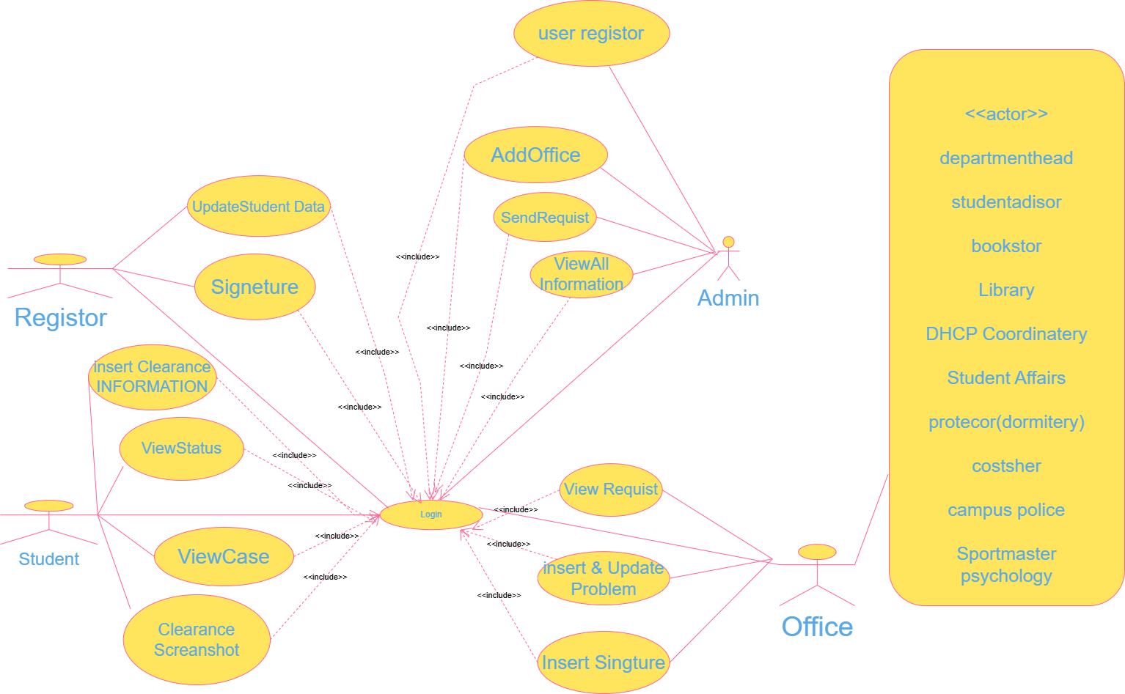
Figure 1 System Use case diagram

Use Case Identification
ID | USE CASE NAME | INCLUDES
UC1 | Login | Open the System
UC2 | Create Accounts | UC1
UC3 | Manage Accounts | UC1
UC4 | See Feedbacks | UC1
UC5 | Record property Information | UC1
UC6 | Prepare Approved Form | UC1
UC7 | Announce properties debt | UC1
UC8 | Request For Approval | UC1
UC9 | Generate Report | UC1
UC10 | View Report | UC1
UC11 | View Status | UC1
UC12 | View Recorded Information | UC1
UC13 | View Properties Information | UC1
UC14 | Update Properties Information | UC1
UC15 | Print Approved Sheet | UC1
UC16 | Give Feedback | UC1
UC17 | Logout | UC1
Table 3 Use cases
2.4.1.1 Use case documentation
1. Use case description for login.
Use case name | Login
Actor | All System Actors
Description | Help users to login into the system by their user name and Password.
Pre-condition | Users must have an account before
Post condition | The authenticated user can be able to login into the system.
Basic course of action | User action | System response
 | 1. User opens the system.  3. User fills user name andpassword and then click login Button  .6 Use case ends | 2.The System displays Login page  4. The system validates the Entered information.  5. User’s page displayed.
Alternative course of action | If invalid “username or password” is provided, the system display error message and the process resume from step 3 above.
Table 4Use case description for login.
2. Use case description for Create Account.
Use case name | Create Account
Actor | System Admin
Description | The system admin create accounts for the users to get access to the system.
Pre-condition | System Admin must login into system.
Post condition | The users of the system can login and have their own account.
Basic course of action | User action | System response
1. The Admin open the system 3.The Admin enters his/her Username and password  .6. The Admin click create Link and fill user’s profile.8. The head click create button. | 1. The Admin open the system  3.The Admin enters his/her Username and password.  6. The Admin click create Link and fill user’s profile.  8. The head click create button. | 2. System displays the log in Page.  4. System validates information’s provided by the Admin.  5.The Admin page displayed  7.form validates the provided information  9.Use case ends
Alternative course of action | If the information entered is invalid or incomplete at step 3 above, the system displays “error message ” The process returns to step 3.
Table 5Use case description for Create Account.
Table 6Use case description for Request for approve.
Use case name | Request for approve
Actor(s) | student
Pre-condition | The actor cannot Request the information
Post-condition | The Actors will be Request
Description | The actor requests different offices to be approved.
Typical course of action
  Actor Action | System Response
  Step1: the actor opens the system  .Step3: User fills user name and password and then click login button.  Step5:user select request for approval button.  Step7: user fill necessary information’s. | Step2: The System displays Login page.  Step4: The system validates the Entered information. Step4.5: system display home page for the user  .Step6: the system displays request form.  Step8: the system valid and check inserted information.  Step8.5: the system send request to corresponding offices, then notifies when the offices replay for his request.  Step9:Use case end

2.4.2 Sequence Diagram
Sequence diagrams are used to show how objects interact in a given situation. An important characteristic of a sequence diagram is that time passes from top to bottom: the interaction starts Near the top of the diagram and ends at the bottom.
Generally, a sequence diagram shows object interactions arranged in time sequence. Some of use case sequence diagram for the system are shown as the following:
- Sequence Diagram for login

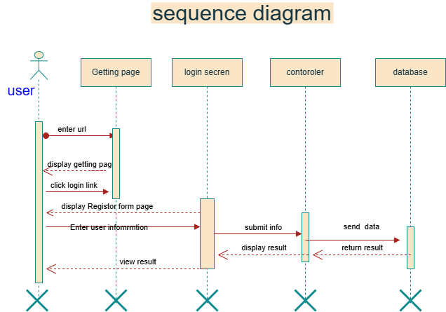
Figure2
- Sequence diagram create account
- Sequence diagram homepage student form
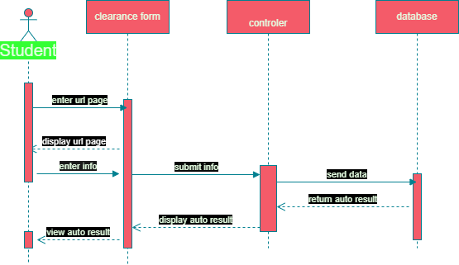
Figure3

- Sequence diagram home page enrollment form
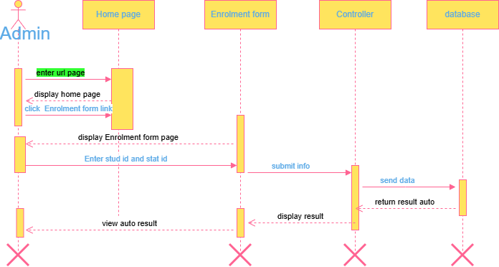

- Sequence Diagram home page in case form
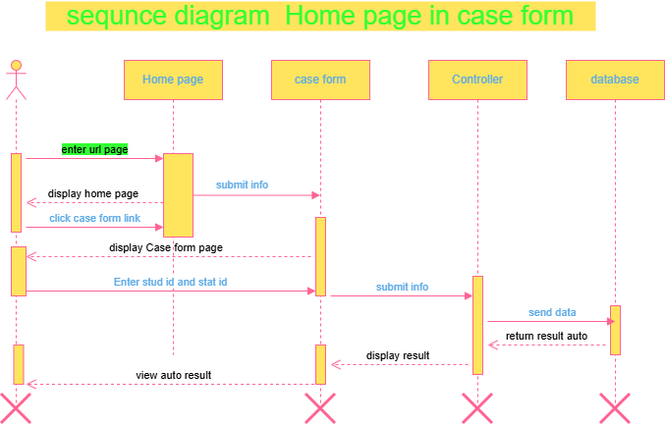
Figure5

- Sequence Diagram home page in register form
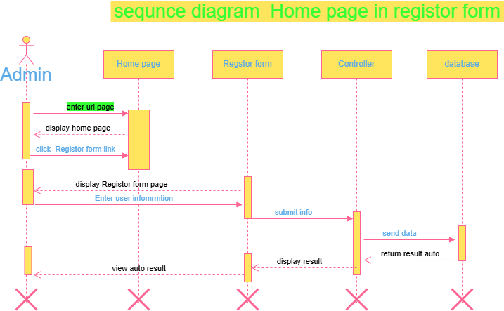
Figure 6

2.4.3 Activity Diagram
Different points in the flow of control. It is essentially a flow chart that emphasizes the activity That takes place over time. Activity diagrams can be used to model higher-level business process at the business unit level, or to model low-level internal class actions. It is "Less technical" in appearance, compared to sequence diagrams, and business-minded people tend to understand Them more quickly.
- Activity diagram for Login form

Figure7
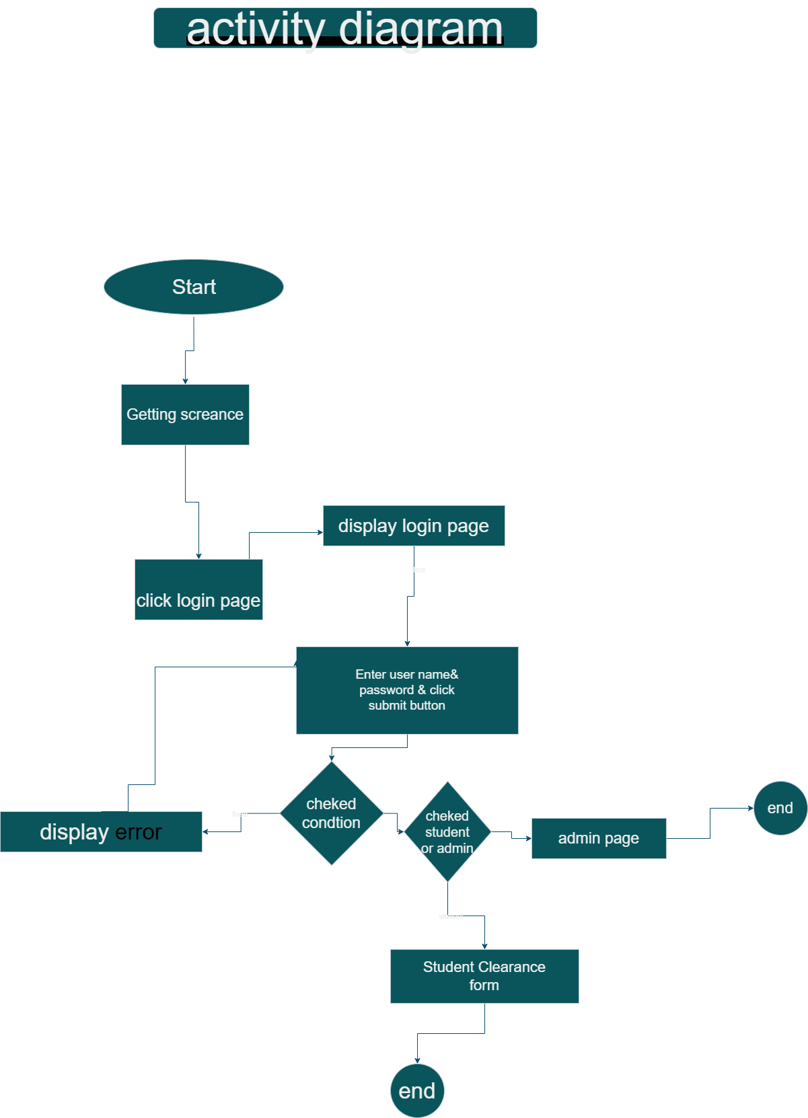Activity Diagram from create Account
Figure 8

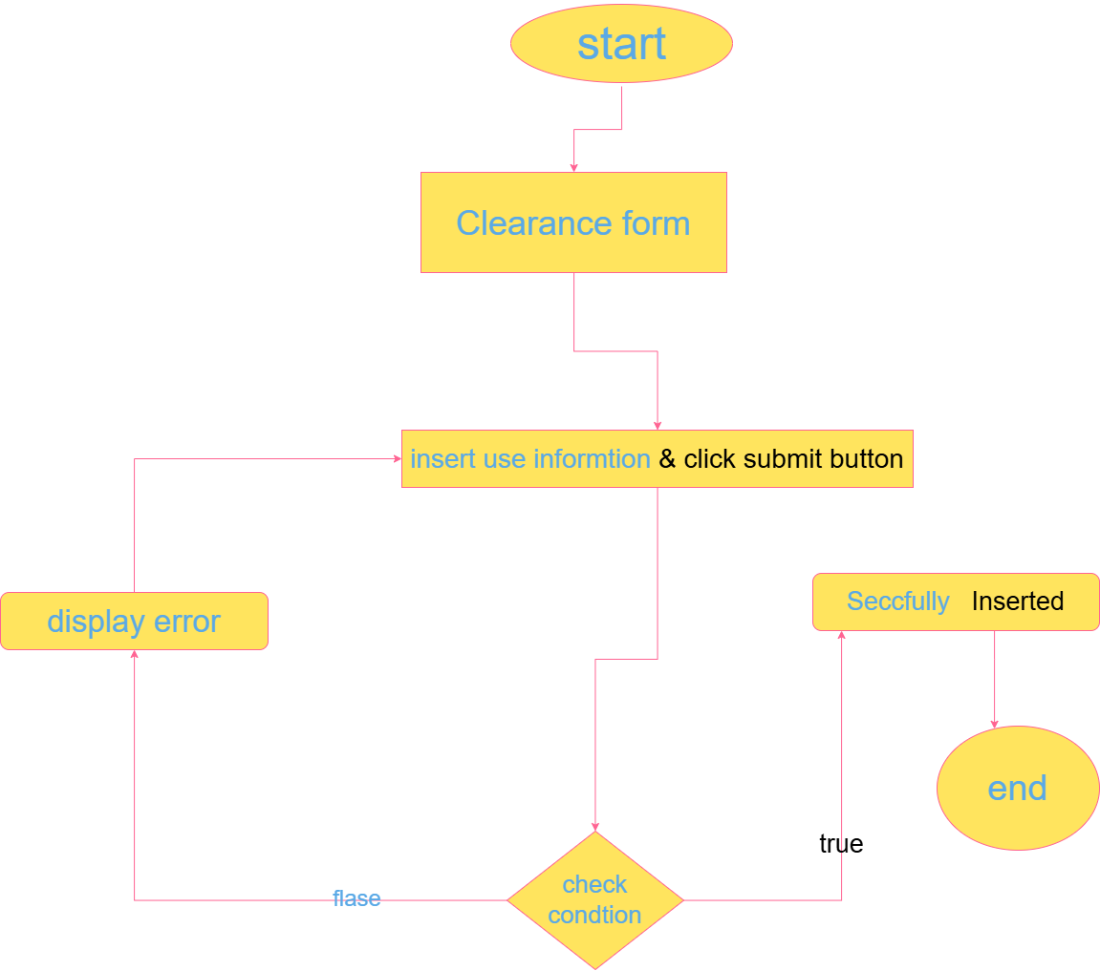
Activity diagram for submit office
Figure 9

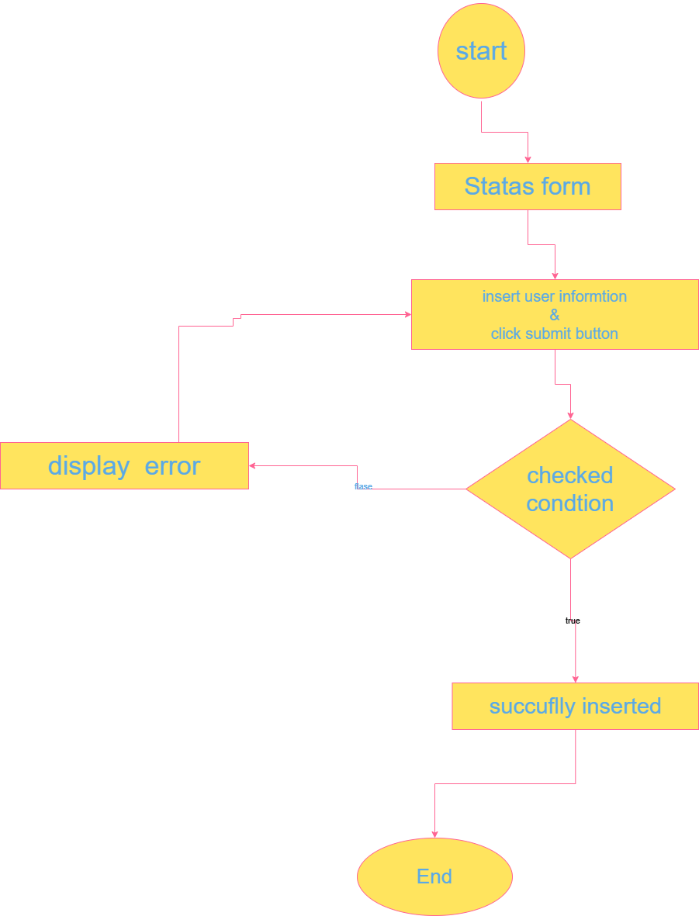
Activity diagram for update case
Figure 10

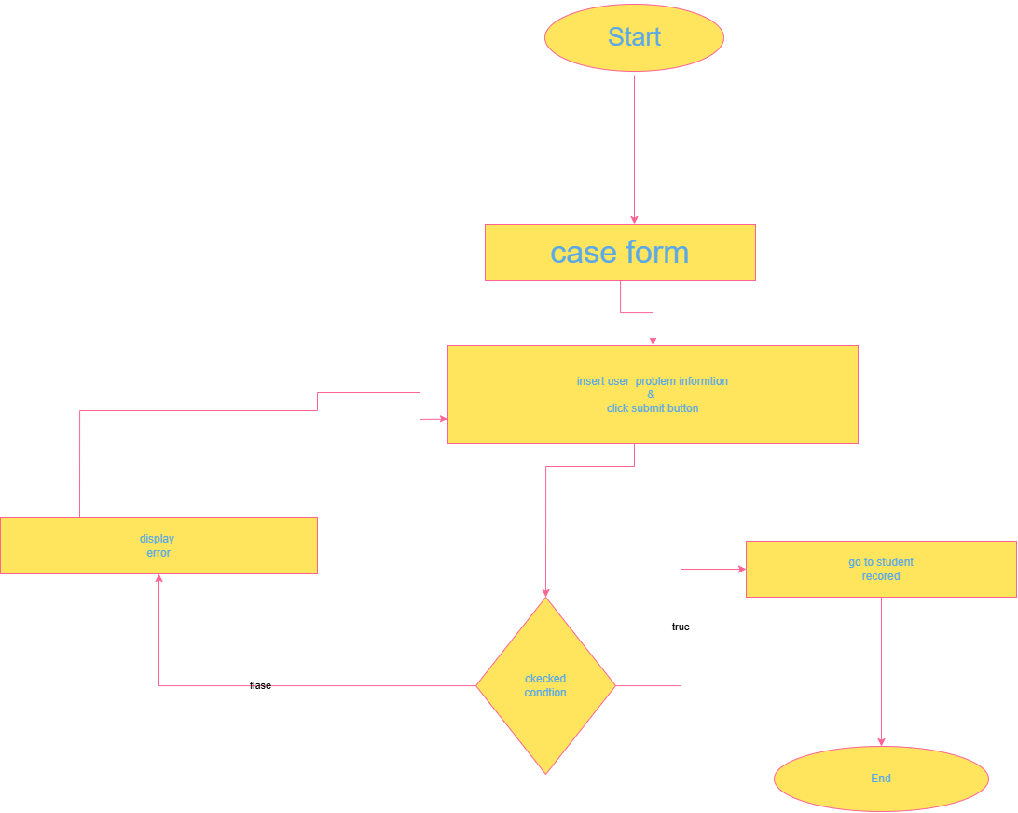
Activity diagram generate report
Figure11

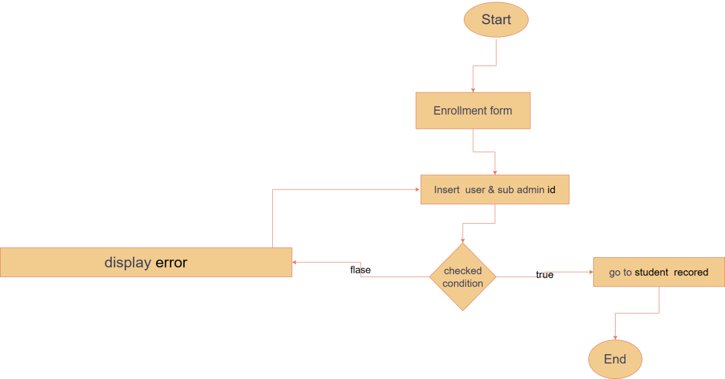

- Class diagram
- 2.4.5 Class diagram
- A class diagram is a type of static structure diagram that describes the overall structure of the system by showing the systems classes, their attributes, operations or methods and relationships among objects.
- Classes are represented by rectangles with three sections. These are: -
- ⎫ The top section is the name of the class
- ⎫ The middle section contains the attributes which store information about an item
- ⎫ The bottom section contains the methods/operation that show what are done on object or
- class. The class Diagram below shows the class of our system, them inter relationship
- (including inheritance and association) and the operations and attributes of each classes.
- Class diagram
- Figure12

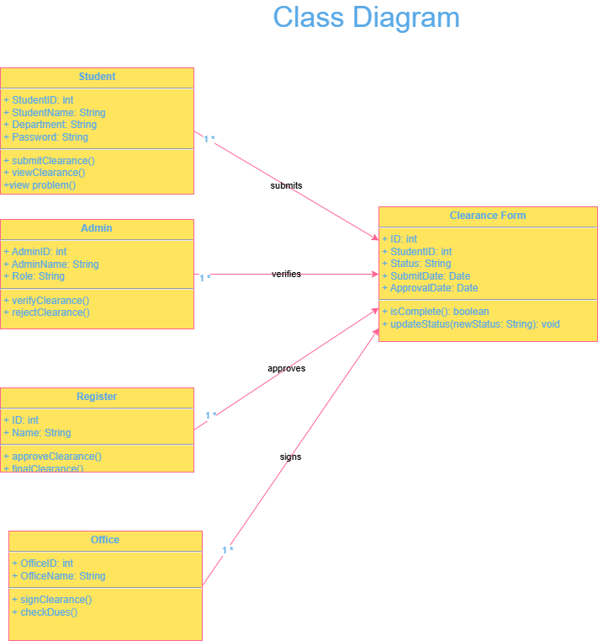
2.5 User interface design
The Proposed system has several user interfaces to communicate easily with the User. Our team Attempt to illustrate this interface in general as follows:
─ The system user interface should be consistent with all other program.
─ The caption and the test of user interface should be self-descriptive and clear to Understand.
─ The user interface should be easy to understand. ─ The user interface should be customized.
─ The user interface should be accompanied with help files that describe the usage of each user interface.
Our system contains the following user interface: -
- USER INTERFACE DISGN
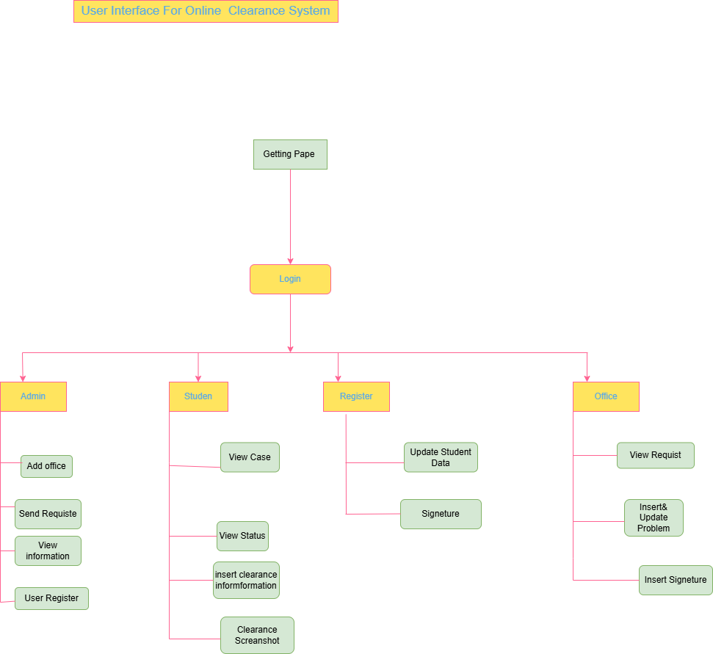
Figure13

Chapter three
SYSTEM DESIGN
3.1 Purpose and goals of design
Purpose
The purpose of the system design is to transform the requirements into compete and detailed system design specification, to provide sufficient detailed data and information about the system and also to make coding and implementation easy for developers. Generally, our system is designed to implement a solution for problems of the existing manual system of MAU clearance process.
Goals of design
✓Design goals describe the qualities of the system that developers should optimize. Such
as: -
Performance: - The system should have faster response time as it operates as expected over specified time interval.
Reliability: The system should be reliable by using operating systems that provide backup systems.
Security- The system has login page it allows only the user who have privilege to access the system therefore the system can’t be accessed by unauthorized user.
Maintainabity: the system should be easy to maintain and improve at any time.
Readability: The system should be easily written in easily understandable codes and should have comments so that any user can read it easily.
User interface designs: The system should have a user interface that are suitable for use for the user and should have good look and feel for the user’s interest.
Utilities: The system should provide supporting manuals for use like help and support menus.
3.2 Current Software Architecture
Currently there is no software architecture for the MAU clearance system. The current system is paper based manual system that is stressful and tedious. It also needs a lot of time, labor and resource.

3.3 Proposed software Architecture
3.3.1 Subsystem Decomposition
Subsystem decomposition is the process of decomposing the system into smaller subsystem in order to easily understand the design and maintain the system. our system decomposed into six subsystems such as: -
● The User Interface (UI) Subsystem: this subsystem is responsible for
• Taking user input
• Passing user inputs to server
• Display system messages
● The Database Subsystem: this subsystem is responsible for
• Receiving requests from different subsystems
• Sending information to different requesting controllers
● The administrator task subsystem: this subsystem is responsible for
• Creating accounts
• Viewing feedbacks
• Managing account
● The Student task Subsystem: this subsystem is responsible for
• Requesting for approval
• Viewing generated report
• Generating feedback
● The officer task Subsystem: this subsystem is responsible for
• Updating property information
• Viewing property information
• Approving the clearance
• Generating feedback
● The registrar task subsystem: this subsystem is responsible for
• Preparing approved form
• Approving
• Viewing approval status
• Generating feedback 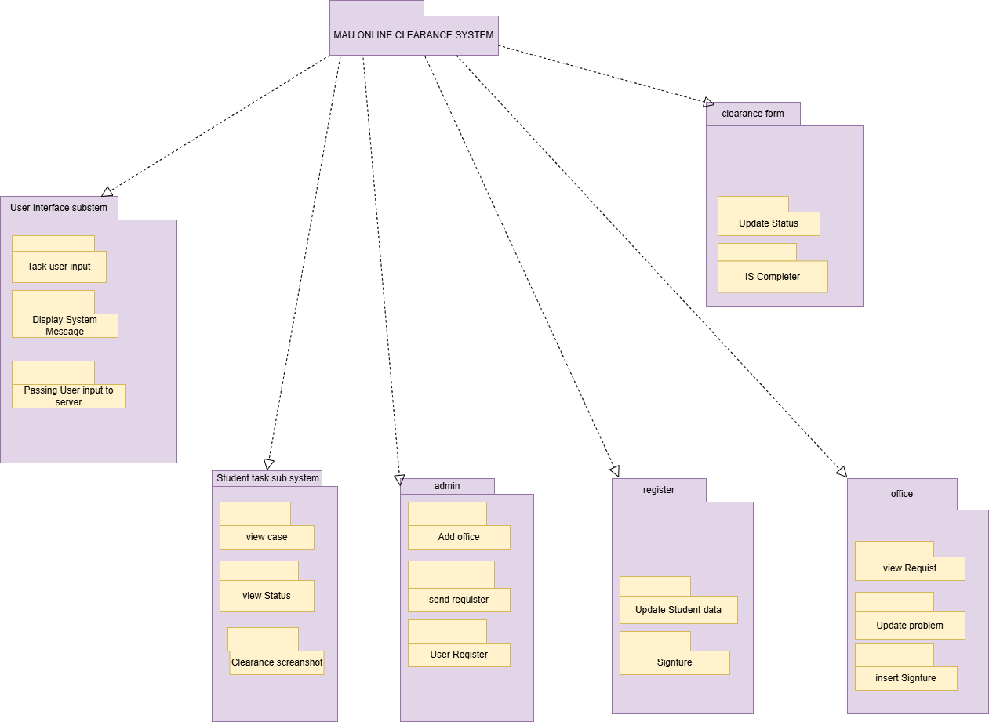

Figure 14 Subsystem diagram
Architectural view
I. Overview
To design our system, we are going to use three-tier client/server software architecture because in three tier architecture each tier runs on its own infrastructure; each tier can be developed simultaneously by a separate development team, and can be updated or scaled as needed without impacting the other tiers
II. Architectural layer
Three-tier architecture is a well- established software application architecture that organizes application into three logical and physical computing tiers such as the presentation tier, the application tier and the data tier.
✓ Presentation tier-the presentation tier is the user interface and communication layer
of the application, where the end user interacts with the application. Its purpose is to take
request from the client and displays information to the client. It communicates with other
tiers using a web browser.
✓ Application tier-the application tier, also known as the logic tier or middle tier is the
heart of the application.in this tier, information collected in the presentation tier is
processed.it process the client’s request and sends it back to the client. it also interacts
with the server that stores the data.
✓ Data tier-the data tier, sometimes called database tier, data access tier is where the
information processed by the application tier is stored and managed.it is used to store the
processed information so that it can be retrieved later on when required. The
communication between the presentation tier and data tier is done by using application
tier.
Figure 21 Architectural layer diagram
III. Hardware and software mapping
a) Component Diagram
Components are generally units of computation or operation in the system. A component has a
name, which is generally chosen to represent the role of the component or the functions online
Student Clearance management system for Mekdela Amba University. The different components
of a system are likely to interact while the system is in operation to provide the services expected
of the system. After all, components exist to provide parts of the services and features of the
system, and these must be combined to deliver the overall system functionality.
Figure 22 Component diagram
3.6 Access Control & Security
The main actors of the system are student, offices and Admin. Accordingly, the following access control list is given for the system. Each column`s name specifies the privilege class and the rows specify users whose access is to be controlled. If there are operations (of the class specified in the corresponding column) in a given cell (column and row intersection) then the user in that row is said to be given an access to these operations. If there is no entry in a given cell, then it can be considered as that user has no way of contacting or using the class through the operation corresponding to the column of the cell.

Actors | Privileges
User | Clearance | Report | Record | Material Information | Feedback | Account | Password
Admin | create () Search () Update () Delete () View() | Receive() | create () Update () View() | Set () Change()
Registrar | Prepzare () Approve() | Generate () Send() | Give() | Update () View () | Change()
Bookstore Library Circulation Proctor Sport master | Approve() | Generate () Send() | Update () View() | Give() | Update () View() | Change()
Other offices | Approve() | Generate () Send() | Update () View() | Give() | Update () View() | Change()
Student | Request () Print() | View () Receive() | Give() | Update () View() | Change()
Table 12access control Reference Books
3.7User interface design
The user interface design represents the front end of the Web Client, and contains the actual GUI elements that users view and click. The user interface is based on a modular Flex application, hosted on the Web Client application server that runs in the user’s Web browser. The user navigation controls.

- user interface design for Getting 
Figure 19

- user interface design for Login Page
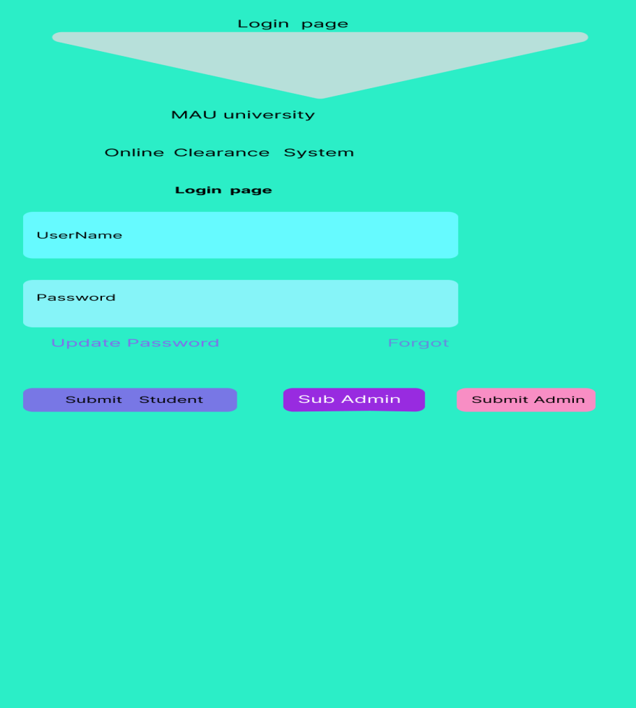

Figure 20
- user interface design for Admin Page
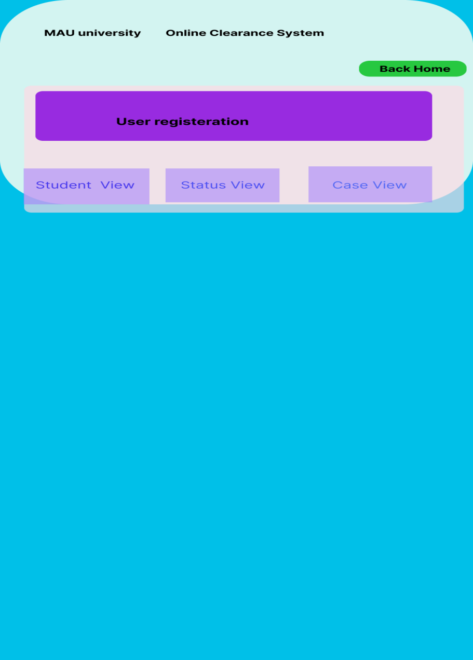

Figure21
- user interface design User Register page
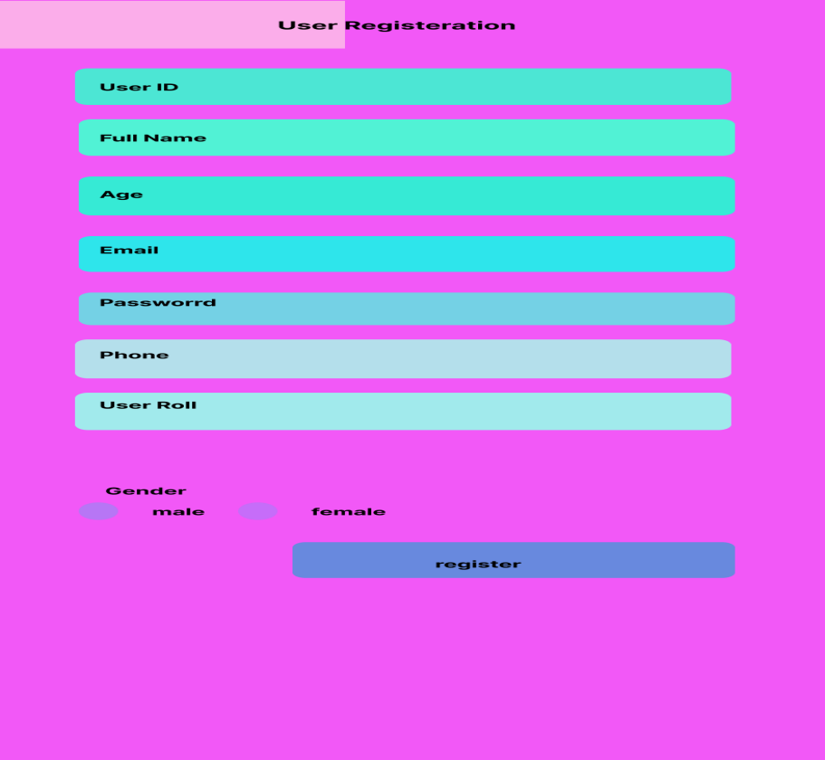

Figure 22
- user interface design for Student Dashboard
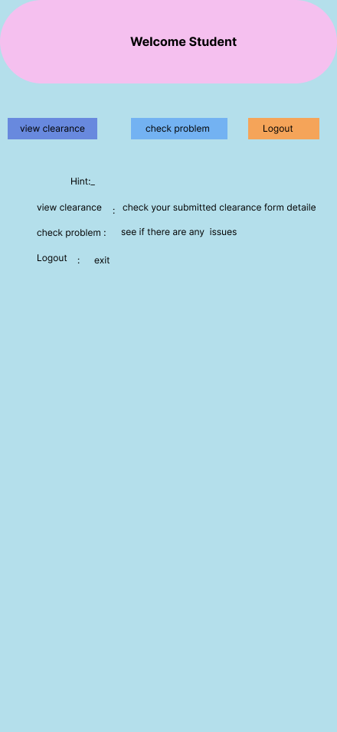

Figure 23
- user interface design for MAU Student Clearance Form
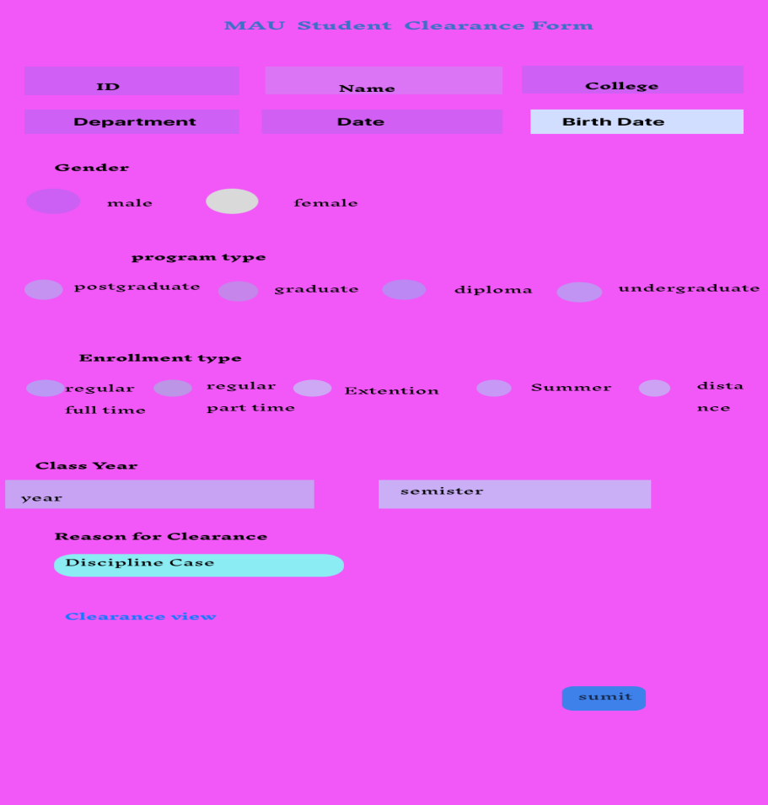

Figure 24
- user interface design for Register Successfully
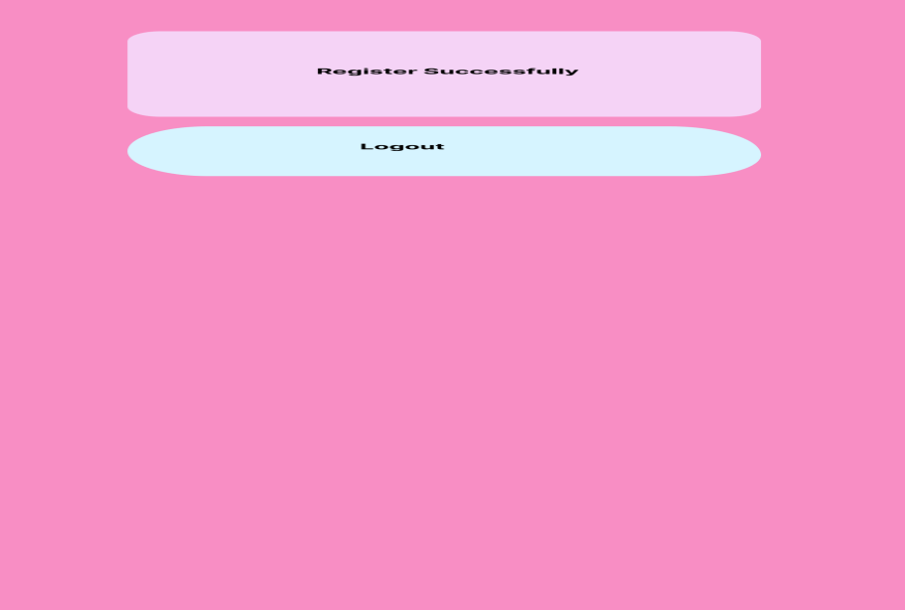

Figure 25

Reference
Books
▪ Object Oriented Software Engineering using UML, Patterns and Java Second Edition by Bernd Burgge and Allen H.Dutoit
▪ Design and Implementation of Student Clearance System (A Case Study of Caritas University)
▪ Alain Abran, École de technologie supérieureJames W. Moore, The MITRE Corp. (2004 Version) Guide to software engineering body of knowledge 2004 Version▪The Unified Modeling Language Reference Manual, James Rumbaugh, Ivar Jacobson and Grady Booch, Addison Wesley, 1999.
Website
▪google
▪http://www.cs.mu.oz.au/▪ http://www.developer.com/design/article.php/1553851/ ▪http://www.agilemodeling.com/

